# Contents

Installation 2

Uninstaller 2

About the Game 3

The Missions 3

Your Career in the Army 3

Assignment of Objectives 4

The Puzzle 4

Level of Difficulty 4

Some Geographic & Historic Concessions 5

Playing the Game 6

Viewing the Environment 6

The Game Interface 8

Selecting Characters 15

Moving Around the Map 17

The Characters 24

The Commandos 24

Special Characters 29

The Enemy 29

Equipment 34

Objects Selected with One Click 34

Objects that Can Be Placed on the Scenery 36

Objects Selected with Two Clicks 38

Weapons 42

Vehicles 44

Driving Vehicles 44

Single Player Game 45

Multiplayer Game 46

Setting Up 46

In-Game Differences

Between Single Player & Multiplayer 48

Credits 50

Eidos Interactive Technical Support 52

) 1 )

# INSTALLATION

If your computer has the Autorun option activated, automatic installation will begin as soon as you insert the first Commandos 2 CD into your CD drive.

If Autorun is disabled, you will need to select the option “Explore” on the icon of your CD unit with the right mouse button (RMB) and run the exe file “Setup.exe” in the root directory of your CD.

The “Install Shield Wizard” will start and after it the license window will appear. If you decide to accept the terms, the next question will be “Where do you want to Install Commandos2?”

All the game files will be saved in the same folder, whose default route is:

## **\Program files\Commandos2**

But of course, you can change it as you wish.

Finally, you will be asked if you want to install the DirectX8.0 files. If you decide to do so and your system already has them. they will not be reinstalled, although if necessary they will be upgraded.

If you have enough space in the hard disk, the game installation will start.

When it is finished, if you clicked “Yes” when asked about installing DirectX8.0, the program will check your current version of DirectX and decide whether to install it or not.

Depending on your operating system, you may have to restart your computer for the system to acknowledge the changes made. It will tell you what to do in order to start training with your Commandos as soon as possible.

## UNINSTALLER

**Remove and Repair:** Application that, before removing anything, will offer you the following three options:

**Modify:** In case you want to change some of the options that you chose when installing.

**Repair:** Checks the files in game folder and, if it encounters any problems, will try to fix them by reinstalling the necessary files from the CD.

**Remove:** Remove all the files you installed and change the registry file.

2

About the Game

## The missions

In Commandos 2: Men of Courage, you have to successfully take your men through a series of missions inspired by events that took

place during World War II. The missions have several different

objectives, new challenges and many possible approaches that will depend on your tactic, skills and weapon dexterity. All the missions have at least one main objective: rescue, espionage, assault or defend. Missions also include sub-objectives and clues that will take you closer to your goal. If you don’t complete your objectives or if you lose some of your team, you will have to try again.

In creating Commandos 2: Men of Courage, we have tried to make an enjoyable game that is more than just a faithful depiction of Commandos activity during WWII. So please note, if your history book contradicts what you see in the game ... trust your history book.

## YOUR CAREER IN THE ARMY

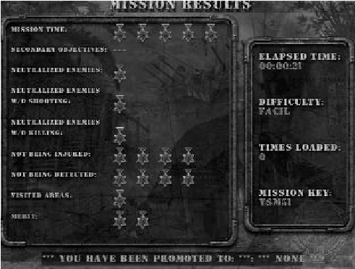The army life is a hard one and to excel you must complete the objectives set out before and during the mission. Once you have completed a mission, you will be able to move to the next one. Each time you successfully finish a mission, you will be assigned a number of points according to your degree of success. The points are based on the number of secondary objectives accomplished, the time it took you to finish, and the damage you received. Not being detected and visiting different areas of the map also influence your points.

The number of enemies neutralized is also a factor when scoring points. You get maximum points if you tie them up, fewer points if you kill them with a knife and the fewest points of all if you kill them with a firearm.

As you progress through the missions, your points will continue to accumulate and your rank should increase. When you start the game you are the lowest rank. By the time the war ends, if you have successfully completed the missions and displayed exemplary behavior you could attain the rank of Field Marshal. Your honor and your career depend on how effective you are ... and your pension depends on it too.

3

## Assignment of objectives

At the beginning of each mission you will receive brief instructions on what is expected from you and your men. You will be given information in the following areas:

* The overall strategic situation.
* The main mission objectives.
* A tour of the environment, at which point you will be shown where theobjectives can be completed and the position of key areas. You’ll also receive some advice on the tactics you should employ.

If you would rather skip the briefing, press the “Esc” key at any point to start the mission. If you need to check any of the objectives while in a mission, you can use the notebook in the interface.

## The Puzzle

A selection of missions contain pieces of a puzzle. If you can collect these pieces and finish the game you may unlock special missions.

The pieces are scattered all over the map. They could be found on the floor and also inside boxes, cabinets, enemy inventories,

and anywhere items can be stored. The objects will be stored in a table that you can access via an icon placed at the top of the interface.

## Level of difficulty

The objectives of a particular mission will not change even if the difficulty level is altered. The differences you will experience from one difficulty level to the next will be in the behavior of your enemies and the supply of tools and provisions.

For example, in Normal difficulty, enemies will be less likely to leap into action and will take their time recognizing and shooting at you. Your firearms have the longest range and shoot extremely fast. Your enemies are more relaxed and their reaction times are far longer, giving you a larger margin of error. If one of your Commandos’ health levels drops to zero, you can bring him back from the brink of death by using any of the multiple first-aid kits you will find. There is no shortage of ammo and items and grenades and explosives have a larger damage radius.

In Hard difficulty, you will encounter more enemies, the range and speed of your firearms is decreased and the time that it takes the enemies to react is faster.

Enemy firearms are more deadly. When one of your men dies, there is no way to bring him back.

In Very Hard difficulty, the enemies react as soon as they see you, the range of their guns is the longest and their shots even more deadly. First-aid kits and ammunition are in very short supply; success could rely on a single bullet so they must be used wisely. Just in case this isn’t enough, enemies recover from being knocked out by Commandos far faster. Wine will also affect them for a shorter period of time.

## Some GEOgraphic & historic concessions

We know that ...

* There are no penguins in the Arctic.
* The submarine bunkers at La Pallicein La Rochelle had more than three hangars.
* The bridge over the river Kwaiexists, but it is not made of wood and it was never destroyed.
* The statue of Buddha is not in Indiabut in a temple in Kyoto, Japan.
* The Shinano was sunk before entering into active combat.
* There are no piranhas in Asia, only in the Amazon river.

|  |
| --- |
| 4 5 |

The dates and historic events are based in real ones but have been adapted for gameplay reasons. We maintain that you should always trust your history books — this is a video game after all!

# PLaying THE GAME

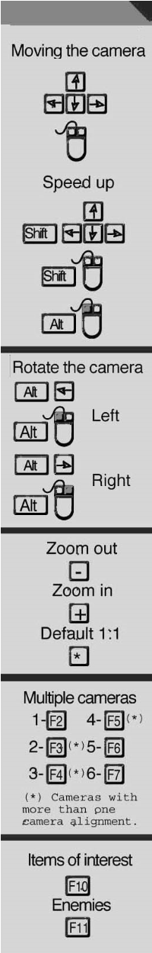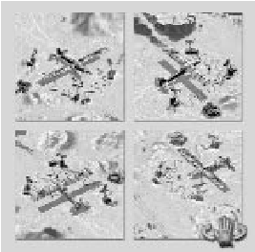This section contains information regarding the core areas of Commandos 2. You will be given information about your men, the weapons you will use throughout the missions and the various tactics that will help you accomplish your objectives. Reading them does not guarantee your success, but will help you recognize your options, rate the enemy's chances and anticipate the different perils you will have to face. Good luck and go for it.

## VIEWING THE ENVIRONMENT

### MOVING THE CAMERA

From the moment a mission starts you can freely scroll the camera around the whole external environment. It is highly recommended that you do this prior to issuing orders. Doing this will give you a better indication of the global situation.

You can use the cursor keys on the keyboard to move the onscreen cursor toward the screen boundaries. When the screen stops moving you have reached the edge of the map. You can reach every corner of the map in a much faster way if you do the same movements described while keeping the “Shift” key pressed, or by pressing the “Alt” key and moving the mouse at the same time.

### ROTATING THE CAMERA

If you move the camera around the map, many of the areas will be hidden by houses, walls, furniture or vegetation. To view the whole environment you must combine the normal moving around the map with the three other camera angles.

If you keep the “Alt” key pressed and press

### ZOOMING IN AND OUT

You are able to change the zoom level of a map. Use the

“-“ key to zoom out and observe a larger area of the map. Alternatively press the “+” key to zoom in to view specific

areas of the environment.

Whenever you want to revert to the default viewing scale, you can use the “+” and “-“ keys or press the “*” key on the numeric keypad.

### MULTIPLE CAMERAS

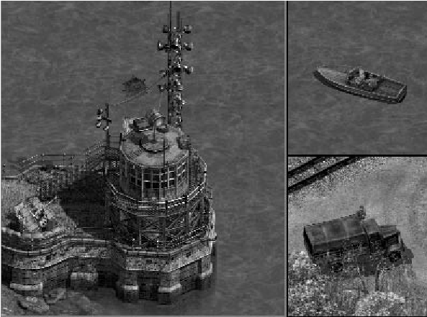Sometimes your men or your targets will be scattered around at different points of the environment. In positions like this you may want to keep track of what is happening at each of these points without having to move the camera manually.

The Multiple Cameras function will divide your main screen into several window configurations when you press the function keys from “F2” to “F7.”

This will allow you to coordinate the action at different points. Please note that some of the function keys have alternating window configurations: one configuration for one press and another for two presses.

Each section behaves as a completely independent window. You can select a window by clicking on it with the LMB. The selected window will then be outlined in red. In this active window you will be able to play the game with all its options and features.

To go back to the single window configuration, press the “F2” key. The active window at that point will become the main viewing area and occupy the full screen.

### ENVIRONMENT BOUNDARIES

|  |
| --- |
| the “left arrow” key or the left mouse  button (LMB), the camera will rotate in angles of 90º to the left.  Alternatively, if you press the “right arrow” key or the right mouse button (RMB) while pressing the “Alt” key, the camera  will rotate in angles of 90º to the right.  When inside buildings, passages and tunnels, you can to rotate the camera in exactly the same way as outside. The  difference is that the camera rotation angle is free (i.e. not in  90º steps). This will allow you to examine the interiors from the  6  angle you require. 7 |

The boundaries of every mission are marked by a shadowed zone which you cannot enter, cross or affect in any way.

### LOCATING THE ENEMY AND INTERACTIVE ELEMENTS

As explained in “Rotating the Camera,” your camera position will determine the elements you can see on the map. Press the “F11” key and a red outline will mark the position of all the enemies in that area regardless of whether they are hidden or not.

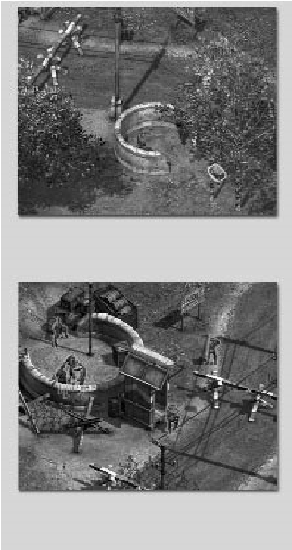

**Key F10**

**Key F11**

In a similar way you can use the “F10” key to locate doors, ammunition, food, tools and other supplies distributed around the scenery. When you press the key, every interactive element on the map will be outlined in red.

These two functions are extremely useful as they provide information on the map and include elements that may be hidden from you. It will help you plan your strategy far more effectively.

Clicking the LMB on the “Map Holder” icon will reveal a sketch of the

mission map. You will see several points with various colors representing

the different elements of the game, as well as a rectangular box

representing the area currently viewable on the screen.

If you click on any part of the sketch, both the rectangle and the viewable

area will move to the new position. Using this method allows you to

immediately locate the areas you are interested in.

To put the map away, click the RMB on the “Map Holder” icon.

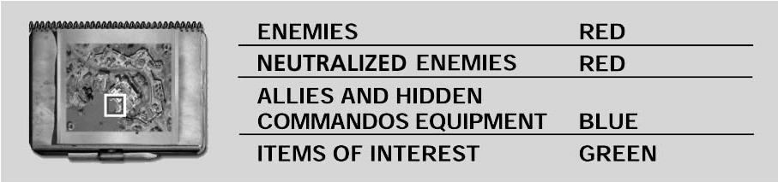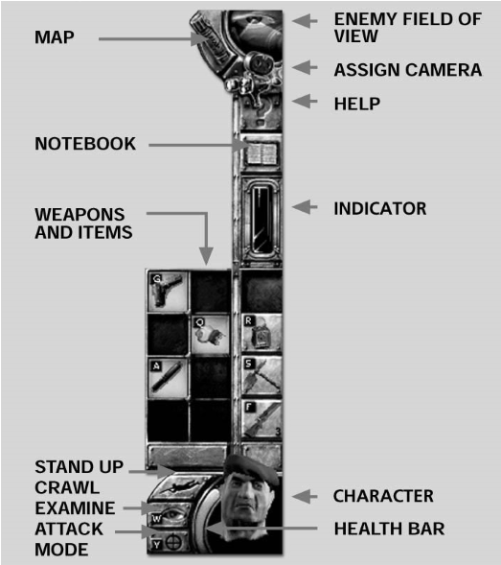

## THE GAME INTERFACE

The interface is your command center. From here you will control the game and give your men the necessary orders to complete the mission. Moving the cursor over the interface options and icons will highlight the ones you are able to use in that particular situation. When you want to use one of them, click the LMB on it or use its hot key. If at any moment you need to use the whole screen, you can press the “~” key (the one directly below the “Esc” key). This will toggle the interface on and off.

### THE CURSOR

The “Arrow” cursor is your principal tool for controlling your

Commandos during the missions. You can move the cursor

around the screen with the mouse, executing an order with the LMB or canceling it with the RMB. The cancel function will only work if the cursor is on the main viewing area and not on

the interface. The cursor is sensitive to the environment and

will change when placed over certain elements. If you press

the “Shift” key as you move the cursor, you will see how it

changes to indicate the different actions you can perform. These include hiding, climbing, and opening doors and boxes.

8

### ENEMY FIELD OF VIEW

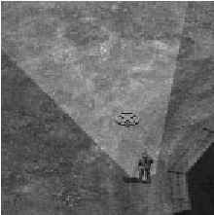Click on the “Enemy Eye” icon in the interface and you will see the cursor

change. When you click on an area of a map, a

red marker is placed at that point. If any enemy

soldiers can see that position, the appropriate enemy

fields of view are displayed.

Enemy fields of view are displayed as a colored triangular area. Avoid these areas as you will be detected if you enter them.

The same cursor, when applied to a specific enemy soldier instead of to a particular point, will display the field of view of that enemy. This will allow you to discover the area he has under surveillance.

Using this tool to observe the movements of the enemy soldiers will allow you to prepare your strategy.

MAP

9

### ASSIGNING A CAMERA

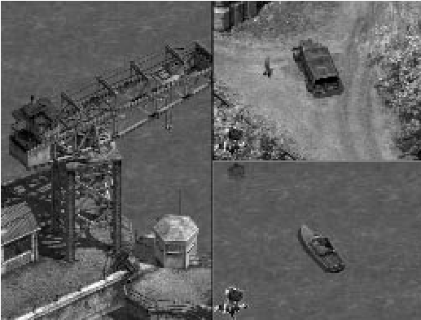Select the camera icon on the interface with the LMB. The cursor will change its form to that of a camera. This indicates that you are now able to select any element of the game, either still or moving, and make it the focus of attention. This element is automatically kept in the center of the screen until the function is deactivated.

When the element has been selected, a camera icon will appear in the bottom left corner of the screen. Clicking the LMB on this icon will deactivate the camera.

You can combine this option with “Multiple Cameras” and assign different cameras to watch different targets simultaneously. Each window can use only one camera, but remember that you can have up to six windows open at any time.

### NOTEBOOK

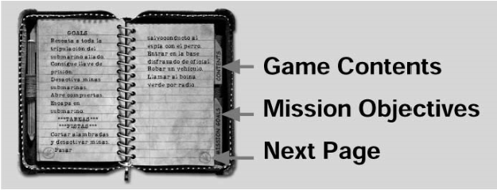If you are unsure about the mission objectives or about any of the objects in the game, you can view the notebook. In it you will find detailed information on the mission, weapons, equipment and techniques. A general help section

is included to aid your success in the completion of more difficult missions.

To view the pages of the Notebook, click the LMB on the subject you want to more information on. You can alternatively click on the arrow icons located at the bottom of each page. While you’re using the notebook, the game will remain paused until you exit. This is done by clicking anywhere on the screen with the RMB.

### HELP

During the game you can also use the “Question Mark” icon on the interface to get information regarding elements contained in the environment. When you select this icon, the cursor will change to a question mark, indicating that when you click the LMB over any element of the mission, the Notebook will automatically open on the page corresponding to that element.

To go back to the game and exit Help mode, click the RMB anywhere over the environment.

STAMINA, OXYGEN AND BODY TEMPERATURE

### INDICATORS

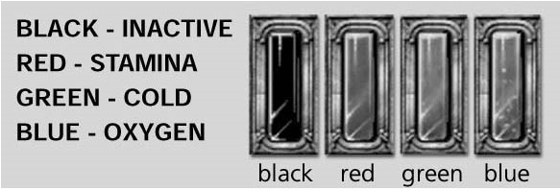Certain activities and areas will involve

dangerous situations. Climbing

and hanging has an impact on

your Commando’s physical

condition that is displayed by a

Stamina indicator in the interface. If the Stamina Bar reaches zero, your Commando will run out of stamina and fall to the floor. Damage incurred is proportional to the distance fallen.

The indicator will also display the amount of oxygen left while your

Commando is swimming underwater. Again, if the bar reaches zero the Commando’s health will decrease and he will eventually drown.

When a Commando is outdoors in the freezing temperatures of the Arctic without the proper clothing, a Body Temperature bar is displayed. If the bar reaches zero, the Commando’s health will fall and he will freeze to death unless you can get him somewhere warm.

### WEAPONS, TOOLS AND ITEMS IN THE BACKPACK

The weapons, tools and items that each character has been trained to use can be controlled through the interface. All characters can carry every item even if they are not trained to use them. If this is the case the item will appear in the Inventory but not in the interface. For example, if the Thief finds a mine and he can pick it up and place it in his Backpack, you will not see it on his interface as he is not trained to use it. He can, however, pass it to the Sapper and it will appear in his interface as he is trained in the use of mines.

|  |
| --- |
| 10 11 |

You have several empty spaces in your Backpack at the beginning of each mission. You will be able to use these spaces to hold items you find along your exploration of the mission. Space in the Backpacks is limited. Clicking the RMB on the Commando face in the bottom right corner of the screen opens your Backpack/Inventory. This displays the number of items you are currently carrying and the space you have left.

CRAWL, STAND UP OR EXIT FROM...

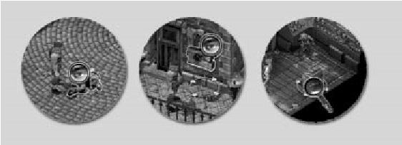

Clicking the “Crawl/Stand Up” icon will toggle between walking or needing to crawl to avoid the enemy in certain situations.

Crawling will allow your Commandos and other characters to move around and avoid being detected in the outer view range of the enemy field of view.

If you decide to walk, your Commandos will be able to move faster but will be easily spotted by the enemies at any of the ranges of their field of view. Please note that the faster you move, the more noise you produce. You can be heard when walking if you are very close to an enemy soldier. Crawling is far less noisy than walking or running.

When you are getting in or out of a vehicle or you’re in a hiding place, the icon on the interface will change to show an exit sign instead of the “Crawl/Stand Up” icon. Click on it with the LMB to exit from the vehicle or from your hideout and move back into the environment.

### EXAMINE

The “Examine” icon on the Commando interface has different uses, all of them of great assistance. Click on the icon with the LMB and the cursor will change to a magnifying lens graphic. If you then move the lens over the environment you will notice that it changes depending on which element it is currently over.

If you click on dead or bound enemy soldiers, allies, boxes or cupboards, your Commando’s Inventory will be displayed as well as a graphic of the soldier’s backpack or the object’s contents. You can then easily select and transfer items to and fro by clicking the LMB on the item you want to move.

The “Examine” ability also has an important strategic function. The game involves both the interior and exterior of buildings. Therefore, your viewable area will not always be capable of displaying what you would find when using a door or climbing a ladder. If you are inside a building and click the

|  |  |  |
| --- | --- | --- |
|  | and you fail to find the means to regenerate your Commando’s health, he will soon die. Should this happen a skull will appear on the interface to remind you of the unfortunate end your soldier has met. |  |
| 12 |  | 13 |

LMB on a window in Examine mode, the external view will be displayed. Enemy soldiers in the area are outlined in red. When you want to return to the interior view, click the RMB on any part of the screen.

If you are inside a building and want to move carefully, select the “Examine” icon and click the LMB on doors, trap doors and ladders. A window will pop up in the top

left corner of the screen. You can move the view angle by

moving the mouse left and right. To exit this mode and regain

control of your Commando, click the RMB anywhere on the screen.

In some missions you will discover switches that activate and deactivate electrified fences, floodlit areas and doors. If you click on them while in Examine mode, a window will pop up displaying the element the switch will activate.

### ATTACK MODE

When the enemy attacks on several flanks, Attack mode will provide a method of placing your men at different defensive points. To activate this mode, the Commando must have a firearm selected. When you select a Commando’s attack mode, he will remain stationary at that point and a field of view will be displayed. Any enemies that enter the area will be shot until killed or until the soldier runs out of ammunition.

To change the field of view direction, hold down the “Ctrl” key and click the RMB in the direction you want the Commando to face. Allied soldiers will place their backpacks in front of themselves for protection. If you change an Allied soldier’s direction, his backpack will remain in its original position. You can use this feature to protect an area different to the direction in which the soldiers are facing.

Some firearms have limited ammunition, so be careful not to leave your men unprotected when they run out of bullets or they will be killed.

### HEALTH BAR

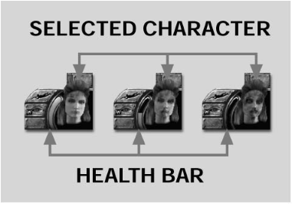This orange bar indicates your general health level. At the beginning of each mission it will always be full. As the mission progresses you may be shot, fall, suffer from lack of oxygen when swimming underwater or freeze in Arctic conditions.

When these instances occur the Health Bar will diminish, indicating your increasingly precarious situation.

Fortunately you will have the opportunity to regenerate the health level of your Commandos when you find a first-aid kit or a tin of food in houses or other areas in the mission. If your health bar continues to decrease

### YOUR CHARACTER

An image of the currently selected Commando appears in the bottom right corner of the screen. His expression and comments aid you in quickly recognizing his current health status and whether he is able to carry out your orders.

### THE BACKPACK/INVENTORY

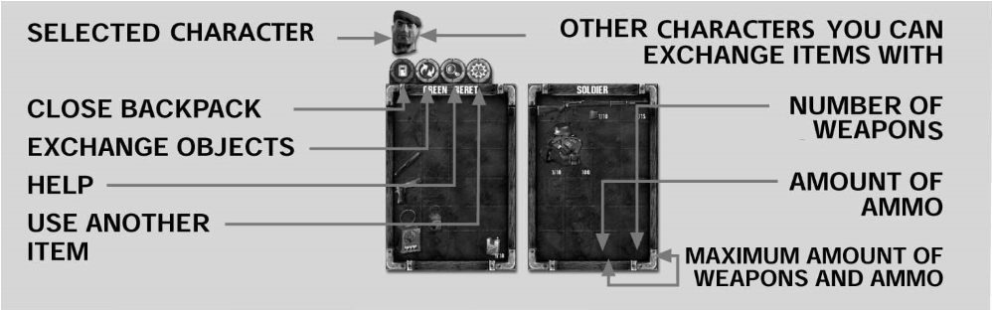

This is where your Commandos store all the objects they have found during the mission. These can include weapons, ammo, food and enemy uniforms. As you play the game you will find alternate ways of opening your Backpack. The easiest way is to click the RMB on the face of the character in the interface.

## Description

The Backpack is displayed as a box divided into sections that indicate the limit on the number of objects that your Commandos can carry. Four icons above the box, from left to right, are: Exit, Exchange, Examine and Use. To select an option, click the LMB on it.

## USES

The most common use of the Backpack is to store objects or exchange them with another character in the mission. To select items in a different Backpack, click

“Examine” and search the contents box, cabinet, enemy or ally. In this way the contents of both

Backpacks will open simultaneously. Click on the item you want to move with the LMB and click again when you want to place in an empty space.

If the background color of the section turns blue, the item will occupy no extra room, so it can share space with an item

you already possess. This is very useful especially with ammunition and weapons of the same kind.

# 14

If the background color turns green, there is space for this object and you can store it in your Backpack.

If the background color turns red, there is no space in the Backpack for that object. This can occur if the Backpack

reaches capacity or the objects you currently possess have been

arranged inefficiently.

You can also pick up items directly from the environment without having to open your Backpack. Hold down the “Ctrl” key and click on the item with the LMB.

To exchange objects with other characters, move your Commando near another and use the “Examine” ability in the interface. The faces of the characters nearby will appear at the top of the screen above your Backpack. Select the “Use” option and click on the face of the character you want to exchange items with; his Backpack will open. To exchange objects, click on the item you want to move with the LMB and click again when you want to place in an empty space.

Some items can be combined. For instance, sleeping pills combined with wine will knock out enemy soldiers. Select one object with the LMB and click on the one you want to combine it with.

To give your Commandos orders, you must first select them. Click the RMB on one of your Commandos. An outline will appear around that Commando and his interface will appear. Your view of the Commando might be obscured by a building, tree or wall. To combat this, each Commando has been assigned a number on the keyboard. By pressing the appropriate number, you can select that Commando. If you press the number twice in quick succession, the screen will center on his position.

SELECTING CHARACTERS

INDIVIDUAL SELECTION

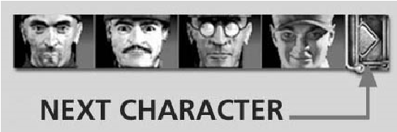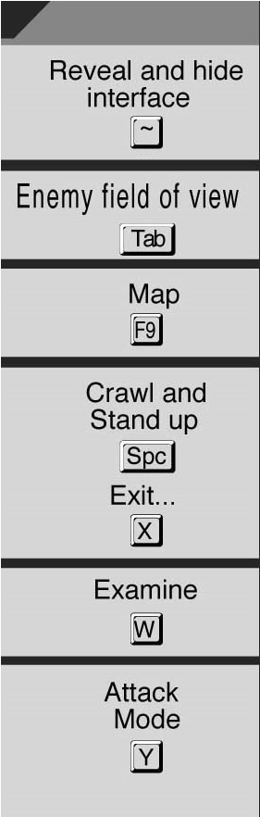

Once you have selected a Commando you can then click the LMB on his face in the bottom right corner of the screen. This will display images of all the other Commandos in that particular mission and their current health status at the top of your screen. If more than four Commandos are present, you can scroll left or right to view the others using the mouse or the cursor keys. If you click the LMB on any of the faces, you will select that character. When you do not want to have any Commando selected, press a number key.

15

## MULTIPLE SELECTION

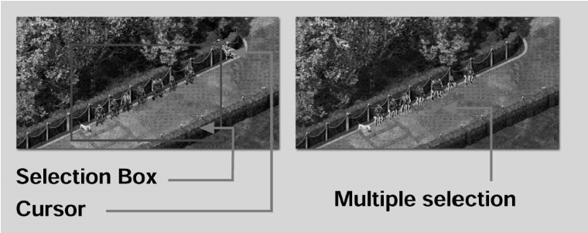

When you want to perform an action involving more than one of your Commandos, you will need to form a selection box. To do this, press and hold the RMB. Drag the cursor in a diagonal direction to create a blue rectangular box around the Commandos you want to select. Once you release the RMB, all Commandos in the box will be selected.

You can also select multiple Commandos by first selecting one Commando and then, while holding down the “Ctrl” key, clicking on another character with the RMB. If you repeat this method with a Commando who is already selected, it will deselect him.

## RELEASING HOSTAGES

Liberate hostages by approaching one with a Commando. Press the “Shift” key and move the cursor over the hostage. The cursor will change to the talk icon. Click the LMB and the hostage will be released and can be controlled in the same way as your Commandos.

## SELECTING ALLIED SOLDIERS

You can select an Allied soldier if you have spoken to him with one of your Commandos. “Lupin” cannot speak with the Allies as he is not of sufficient rank.

|  |  |  |
| --- | --- | --- |
|  | Once in the water, your Commando will swim with the minimum of noise when you click the LMB once on the desired target location. If you require more speed, double-click the LMB and the Commando will swim to the target at a far greater pace. Again faster |  |
| 16 | but far noisier! | 17 |

Once one of your Commandos has spoken with an Allied soldier, the soldier can be selected by clicking on him with the RMB. Alternatively, you can hold down the RMB and drag a box around the soldier or soldiers you want to select. Any soldier within the box will be selected.

## MOVING AROUND THE MAP

WALK, RUN, STICK TO WALLS AND

### MOVE BETWEEN LEVELS

To move your Commandos, click the LMB once on the desired location. Commandos selected will walk to that point. If you want

them to run to that point. double-click the LMB and they will go to

the target as quickly as possible. While running will save time, your haste will create far more noise than walking or crawling. Be wary: if your target location is far away the Commando selected will chose the fastest route, which could mean running into enemy soldiers.

The scenarios are full of enemy soldiers, but your Commandos have a vast range of skills to avoid detection. To avoid being spotted in an enemy´s outer view range, make your Commandos stick to a wall by clicking the LMB on the desired wall. When Commandos are sticking to a wall, clicking on the base of the wall in either direction allows them to move but remain out of sight.

SWIM, DIVE AND SURFACE

crawl to the edge, then click the LMB on the water and

he will enter in silence. You can either select the crawl

icon or press the “space bar.”

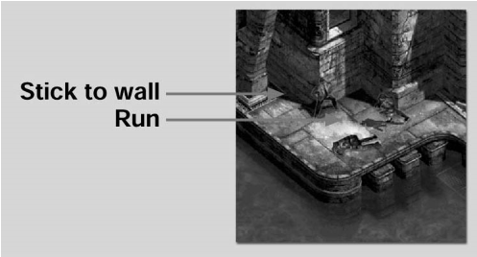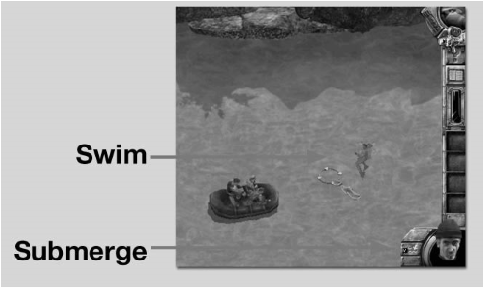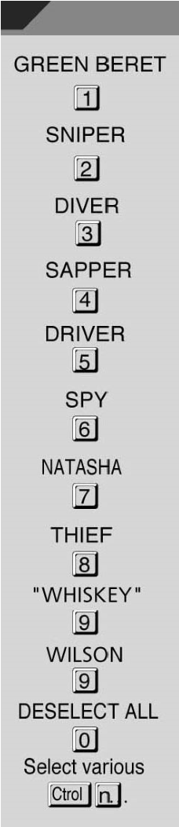

Inside buildings your Commandos can move from level to level using stairs. Note that the cursor will change if placed over stairs, indicating the ability to move upstairs or downstairs. Click the LMB on the stairs and you will ascend or descend. Commandos are able to do this both standing and crawling.

All your men know how to swim and dive.

Click the LMB on an area of water and the Commando will enter it. If the Commando approaches the water in a standing position, he will dive head-first into the water, creating a loud splash that could alert the enemy. If you want the character to enter the water quietly, command him to

If the water is a sufficient depth, your Commandos can swim underwater. This allows them to avoid enemy detection and find alternative paths through the mission.

The ability to dive is indicated by the appearance of a dive icon on the Commando control panel. If you click on this icon the Commando will submerge and an Oxygen Bar will appear indicating how long he can stay underwater. If the bar reaches zero, the Commando’s Health Bar will decrease and his facial animation will turn green, indicating that he is drowning. Commandos have individual attributes; this is obvious when swimming as Commandos can stay underwater for varying lengths of time.

To surface for air, click on the surface icon in the Commando interface. The Oxygen Bar will then fill until completely replenished. If you dive prior to the bar being completely filled, your Commando will dive with that amount of air.

While submerged, click on the “Look Above” icon to allow your Commando to look above the water to view his surroundings. Note that the Oxygen Bar will continue to decrease as your Commando’s nose is still underwater.

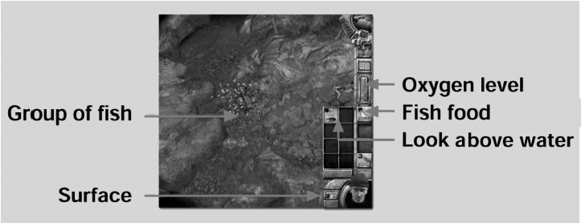If you want to exit the water, click the LMB on the water’s edge and the Commando will crawl out onto dry land. If you double-click, the Commando will stand up and run to the target location.

The only Commando who can stay submerged for an indefinite amount of time is the Diver, who uses diving equipment. He is also the only Commando who can defend

himself underwater as his harpoon gun offers protection from sharks, walrus and crocodiles, but unfortunately not against piranha. While submerged the diver is also able to disarm enemy mines and fight enemy divers. Hiding in shoals of fish is a highly recommended way for the Diver to avoiding detection.

### ACTIVATED ACCESS

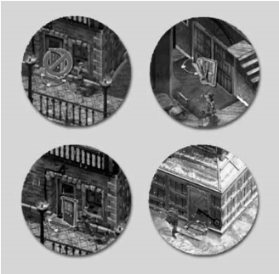Commandos can move around the exteriors and interiors of buildings, aircraft, warships, tunnels, passages, rivers and seas. They can also move around the network of doors, stairs, ladders, windows and tunnels, but some of these must be activated before you can gain entry. Hold down the “Shift” key

and move the cursor to the point where

you want to enter. The cursor will change

when you find a point that allows Commando interaction.

18 Press the “F10” key to highlight all these points.

DOORS, WINDOWS, TRAP DOORS AND LADDERS

To walk through a door you must first ascertain if the door is unlocked. This is done by pressing the “Shift”

key and moving the cursor over the door. If the door is indeed

unlocked, an “Enter” icon will appear. Alternatively, if the door is

locked, a similar icon will appear but with a no entry sign around it.

To open a locked door, you will have to command the Thief to enter the building and unlock the door from inside. If you need to open the door quickly you can command the Green Beret to knock down the door. However, this method is very noisy.

Some doors require a special key. You will see that when you attempt to enter a security door without the key. A blue icon will appear indicating the need to find the correct key. Not even the Green Beret can knock down doors that require a special key.

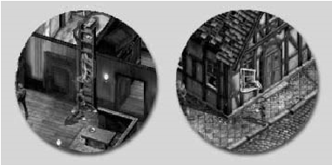Before entering a room, it’s highly recommended that you look inside first. Select the “Examine” icon to the left of the selected Commando´s face, and click the LMB on the opening you want to look through. A small screen will appear in the top left corner showing the contents of the interior. If you

press the LMB you will enter the room; if you press the RMB you will exit this view. If you look through an opening leading outdoors, the screen will switch to the exterior view. You are able to move around, zoom in and out and rotate the camera in this view. If you want to use the opening, click the LMB and the Commando will exit. To leave this view, click the RMB. These rules apply to all openings, from doors and windows to tunnels and trap doors.

If the Thief is looking in through a window, you can order him to enter via the window by clicking the LMB. If the Green Beret is looking out through a window, you can order him to jump. The higher the window the more damage the drop will cause. If you are not looking out of a window, you can perform an emergency evasion by double-clicking the LMB on the window. The Green Beret will run and jump out of it.

To make things easier, when you enter a building all enemies contained within it are outlined in red. You can also press the “F11” key to show the enemies. All enemies on screen will be outlined even if they are in a different room or floor. In the interiors, use stairs and ladders to move from floor to floor. If you hover the cursor over stairs, the icon will indicate that you can use them by clicking the LMB.

19

Ladders work in much the same way as the stairs. Hover the cursor over the ladder and the icon will change to inform you if a click of the LMB is sufficient. While you are climbing ladders you can stop the Commando in mid-climb by clicking the RMB. If you click the RMB again, the Commando will drop to the floor. The damage sustained due to the fall is proportional to the height of drop.

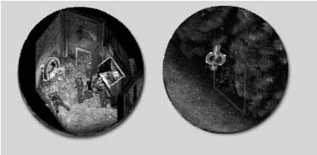You can change direction on a ladder by clicking the LMB above or below the Commando to make him go up or down. This is highlighted by the cursor changing shape when above and below the Commando.

While you are climbing the ladder the Stamina Bar will appear and start to decrease. If it reaches zero, the Commando will fall to the floor and any damage sustained is proportional to the drop.

### HOLES AND HIDING PLACES

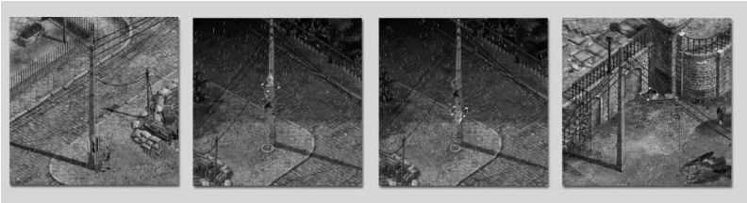Thanks to his small frame and agility, the Thief can sneak around and hide in very small places including in cupboards and under beds and tables. This allows him to assume extremely advantageous positions that will aid the path to victory.

The Thief can use holes in walls as entry points to buildings. Press the “Shift” key and hold the cursor over the hole. If the Thief can enter the hole, the cursor will change to indicate possible entry. Clicking the LMB on the hole allows the Thief to enter and cross to the other side.

The Thief can also utilize hiding places. Hold down the “Shift” key and place the cursor over possible hiding places. If the hiding place is suitable, the cursor will change and the Thief can hide. Press the “Shift” key and click the LMB on the hiding place. While in a hiding place, the Thief is safe from all enemies. The drawback is that he is unable to participate in any way. To exit the hiding place, click any mouse button.

Special passages that all the Commandos can use exist above and below ground. To use them, press the “Shift” key and move the cursor over the passage. Click the LMB on it to enter. You can alternatively press the “F10” key to see items and doors you can access in the current screen.

### CLIMB POSTS AND SWING ALONG WIRES

Posts and cables are another path you can chose to aid in the completion of a mission. Once up a pole you may

be able to access windows you were previously unable to reach.

While you’re at the top of a post or hanging from a wire, enemy soldiers will be unable to see you. The enemy will not see you again

until you run out of strength and fall or descend from the pole.

Only the Green Beret and the Thief can climb the posts and swing along the wires. The Sniper can also climb posts but cannot swing across the wires.

To climb a post, select any Commando who has that ability, press the

“Shift” key and click the LMB on the post you want to climb. Once the Commando is at the top he will swing at the top and stay there until told to do otherwise. If you have selected the Sniper, he will climb to the top and grip the post with his legs so his hands are free for his rifle.

As with scaling a ladder, direction can be affected when you’re climbing poles. Once on the pole, hold the cursor above or below the Commando and click the LMB to alter his direction. This is also displayed in arrow form by the cursor.

|  |
| --- |
| 20 21 |

When hanging from a wire you can swing along it by placing the cursor to the left or right of the Commando and clicking the LMB. To stop swinging across, click the RMB. If you then want to drop to the floor, click the RMB again. The circle directly underneath a Commando swinging along a wire indicates where he would land should he fall or should you chose to descend. Once you commence with the climb, a Stamina Bar appears and begins to decrease. If the bar reaches zero you will fall.

### TAKING AND LEAVING ITEMS

There are weapons, ammunition and provisions scattered around the maps that your Commandos are able to collect and use. You can find these items in cupboards and wardrobes and can also take them from enemy soldiers.

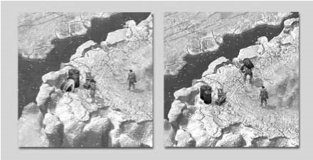To pick up an item. press the “Shift” key, and place the cursor over the item. The cursor will change to a hand icon if you are able to pick it up. If that’s the case, click the LMB. The Commando will pick up the item and place it in his Backpack. You can alternatively press the “F10” key to show items you can interact with in the current screen.

If you want to carry a box or barrel, you can only use the Green Beret. These items are far too large and heavy to place in your Backpack and you will also lose the ability to run. When walking and carrying a large item, clicking the RMB will cancel the walk action. Once you have reached the desired location, click the RMB to drop the item.

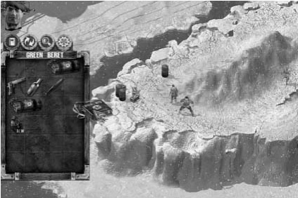You can pick up the bodies of dead or bound enemy soldiers in the same way as picking up larger items. You cannot pick up enemy soldiers until they have been tied up or have been killed. Press the “Shift” key and click the LMB on the soldier. Once you have reached the desired location, click the RMB to drop the burden.

You can dispose of bodies by throwing them out

of windows, into tall grass or at sea. All the Commandos can carry enemy soldiers’ bodies, but the ability to run is disabled for all Commandos during this time.

If your Backpack is full when you attempt to pick up another item, an icon will appear indicating that you cannot pick up the item. If your Backpack is already open and you attempt to place more items into it, a red highlight will indicate that you have no more room. You could try to re-organize your Backpack to create more space. You could also leave items you currently have on the floor to make space for other items you have just found. To do

### THROWING ITEMS

Your Commandos can throw objects in an attempt to distract the enemy. A packet of cigarettes or bottle of

wine can prove a tempting sight to enemy soldiers, who may

then leave their post offering you an opportunity to sneak past or

maybe even sneak up on them!

Select the item you want to throw from the menu. Once it is selected, click the LMB on the desired target. These items can be thrown a limited distance.

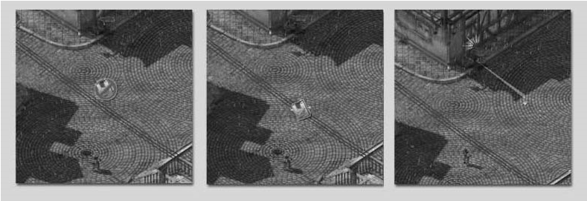

If you are too far away the cursor will clearly indicate this and you will have to get closer to the target. You can retrieve the item from the floor or from the enemy soldier’s Backpack once he has been knocked out or killed.

The Sapper can throw grenades. Select the grenade in the control panel with the LMB and click the LMB on the desired spot where you would like the grenade to explode. You can also throw grenades through doors, windows and trap doors. Grenades have a minimum and maximum distance. Use them wisely as they will kill everyone in the surrounding area.

### SWITCHES IN MISSIONS

You will find electrified fences, floodlit areas and doors activated by switches. You can first examine what effect the switch will have prior to operating it. This is done by selecting the “Examine” icon in the control panel and clicking on the switch. A small window will appear indicating what effect the switch will have.

|  |
| --- |
| this, click the LMB on the item you want to leave and then click again outside the Inventory area. The item will be left at your feet as you may want to pick it up later.  22 23 |

To use the switch, press the “Shift” key and click the LMB on the switch. A small window will appear displaying the effect the switch has caused.

# THE CHARACTERS

When playing Commandos 2, you are the official responsible for a very special group of characters. They are all exceptional and have been thoroughly trained for missions behind enemy lines. Additionally, each one has special skills that you will have the chance to exploit when assigning orders during the missions.

It is also extremely important to know your enemies, and is especially helpful when planning your tactics.

## THE COMMANDOS

### JERRY “TINY” MCHALE (GREEN BERET)

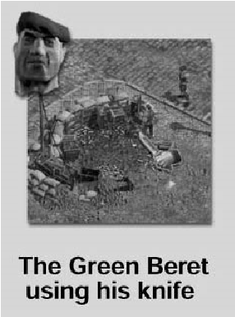Born in Dublin on the 10th of October 1909, McHale was the heavy-weight champion of the Army boxing league from 1934 to 1937 consecutively. He was sentenced by a military jury to 14 years hard labor after knocking out an official, superior in rank. He was pardoned when he accepted the offer to join the Commandos group.

He was promoted to the rank of sergeant after the battle of Vaagso Island, where after being shot in the arm, isolated from his unit and without using a single firearm, he sneaked into a bunker and killed the 16 enemy soldiers inside before returning to the Allied front line.

He is very aggressive and reluctant to accept orders. This is a real problem for his superiors and a nightmare for the enemies.

**SKILLS:** “Tiny” is the biggest member of the group and his tremendous strength allows him to fight, knock out and tie the enemies very quickly. He is able to knock down virtually every door, jump from incredible heights, climb poles and swing along wires. He is also the second fastest runner of the Commandos group and his amazing stamina allows him to withstand flesh wounds and gunshots that would kill any other soldier.

His preferred lethal weapons are his knife and his bare hands. He can use both in deadly combinations especially when he uses the element of surprise. His enemies don’t stand a chance.

RENE “SPOOKY” DUCHAMP (SPY)

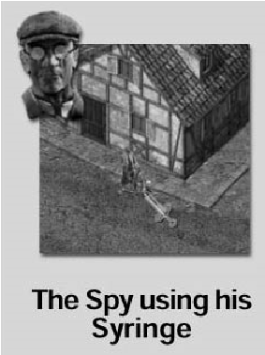Born in Lyon, France on the 20th of

November 1911, Duchamp joined the

French Secret Service when he was 25 years old. He served as Security Chief at the French

Embassy in Berlin, where he learned relevant information about several members of the Hitler Staff. At the start of the war, he joined the French Army and became one of the main active leaders of the French resistance. He has often been a valuable team member of the Commandos group and on many occasions has been of vital help when planning covert assault operations.

His knowledge of the tactics and personalities of the German military has repeatedly proved its use for the English Secret Service.

**SKILLS:** “Spooky” speaks several languages fluently and has a natural instinct for imitation. These talents are invaluable on his missions as a secret agent. One of his most common assignments is to infiltrate enemy lines wearing a stolen enemy uniform and divert, deceive or give deceptive orders to enemy soldiers. His attack involves silent and cautious movement and he attempts to use minimum force if possible.

His preferred weapon is a syringe loaded with a lethal poison that will eliminate his enemies completely and silently.

### THOMAS “INFERNO” HANCOCK (SAPPER)

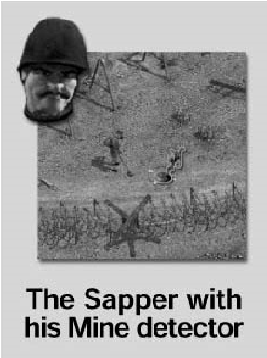Hancock was born in Liverpool on the 14th of January 1911. He took a degree in Chemistry and at 22 joined the Firefighters where he specialized as an expert in High Risk Explosives. In 1939 he joined the army and one year later joined the Commandos group as a volunteer. His profound knowledge of developing and planting explosives has resulted in a string of successful missions. During the assault on Saint Nazare he was responsible for the controlled explosions that flooded the harbor buildings and killed numerous German enemies.

|  |  |  |
| --- | --- | --- |
|  | preventing him from entering water. He can operate other weapons, such as grenades, bazookas, flame-throwers and mine detectors. He can detect and deactivate mines for use at |  |
| 24 | a later time. He can form minefields in areas where enemies and their vehicles will pass. | 25 |

**SKILLS:** “Inferno” is an expert in calculating, placing and developing explosives. The materials he carries in his Backpack are sensitive but heavy, forcing him to move slowly and

### JAMES “FINS” BLACKWOOD (DIVER)

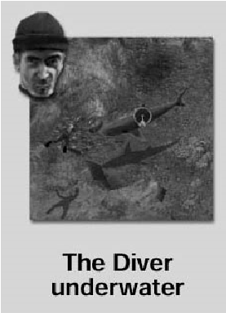Blackwood was born in Australia on the 3rd of August 1911. He joined the Navy where his ability to swim and row greatly accelerated his promotion to the rank of captain. Two years later, his aggressive character and repeated disobedience were to blame for his demotion to the rank of private within the Commandos group. In 1943 he was honored with the Military Cross after his heroic evacuation of 45 men from the beach of Dunkirk after it had been taken by the enemy.

**SKILLS:** “Fins” is a specialist trained for aquatic-based missions. With his harpoon gun and diving equipment he is able to spend hours underwater without worrying about oxygen supply or the danger he may encounter at sea.

On land he has complete mastery of throwing knives and carries a grappling hook that he uses to silently climb buildings, walls and trees.

### SID “TREAD” PERKINS (DRIVER)

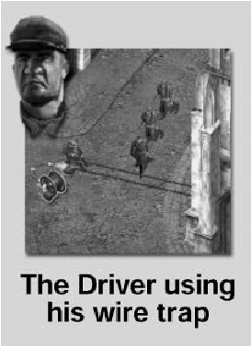This tough soldier was born on the 4th of April 1910 in

Brooklyn, USA. Little is known of the rest of his life but in 1937 he traveled to the UK and joined the British Army. While co-operating with the Foreign Office, he investigated and tested weapons and vehicles taken from enemy armies. During this time he met Paddy Maine, who convinced him to join the Commandos group.

In 1942 he appeared in all the British newspapers when during the course of the assault on the Tamet aerodrome he ran out of ammunition and decided to ram his vehicle against the target. The explosion that destroyed the first airplane produced a chain reaction that demolished most of the aerodrome with astonishing results.

### SIR FRANCIS T. “DUKE” WOOLRIDGE (SNIPER)

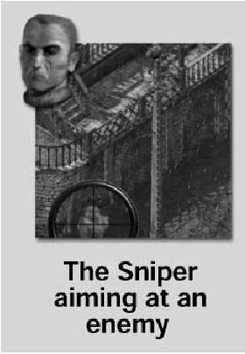Woolridge was born in Sheffield,

England, on the 21st of March 1909, into one of the more influential families of the British

aristocracy. Known among his colleagues as

“Duke,” he is an excellent sniper. His cool temperament and self-control allowed him to shoot and kill the chief commander of the German army with a single shot, at a distance of over a mile, during the Narvik invasion.

**SKILLS:** “Duke” is cool and self-controlled. All his actions are perfectly calculated. Considered one of the best snipers in the world, he very rarely wastes a bullet. His most common missions involve clearing a path for his colleagues and eliminating concealed enemies. He will stand behind windows, poles or other objects that offer shelter while he provides cover for the advancing Commando troops.

### NATASHA “SEDUCTRESS” NIKOCHEVSKI (RESISTANCE OPERATIVE)

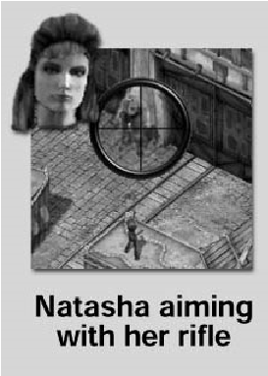Born in Kiev, Ukraine, on the 21st of April 1912,

Nikochevski is the daughter of an aristocrat from the

Netherlands and a Russian dame exiled after the 1917 Revolution. According to her political convictions, she joined the Resistance in her father’s country in 1943. She combines this activity with occasional missions with the Commandos.

|  |
| --- |
| **SKILLS:** “Tread” enjoys fighting the enemy and can drive any vehicle.  His regular tools of choice are gas bombs, smoke bombs, hunting traps and cable to make traps, to name but a few.  26 27 |

**SKILLS:** “Seductress” speaks several languages as her alias shows. She is a fascinating woman but extremely deadly. She is always ready to distract the enemy by combining fluent conversation with an appropriate costume and the help of her lipstick. She is not especially aggressive but is perfectly able to assist the Commandos when necessary. She is a remarkably good sniper, as “Duke” will attest.

### PAUL “LUPIN” TOLEDO (THIEF)

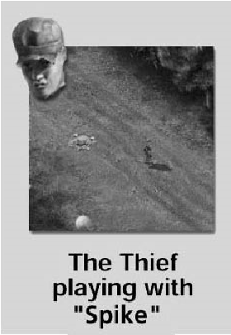Born in Paris, France, on the 1st of March 1916, Toledo is a recent addition to the group of Commandos. When the Germans invaded Paris he decided to start his own one-man war, entering every house occupied by the Germans and stealing every German satchel within his reach. In 1940 he stole René Duchamp’s suitcase, thinking he was a German officer. He was greatly surprised

when he found important documents inside the suitcase and decided to put them into the hands of the French Resistance. From that moment he was recommended by “Spooky” to the Commandos and has been of great help ever since.

**SKILLS:** “Lupin” is the smallest and fastest of all the Commandos. His tiny frame is more than compensated for by his agility to access small areas, break into houses, climb poles, pick locks and exhibit a host of other talents. This allows him to break through enemy lines via avenues other men wouldn’t even consider. He has mastered several martial arts and enjoys stalking and picking the pockets of enemy soldiers. He can also open doors and safes with his tools.

“Lupin” has a pet rat, “Spike,” that he has trained to divert the enemy. His most common methods consist of allowing other Commandos to access buildings. He can enter buildings through windows and holes. Once inside, he opens doors with his tools and keys stolen from Germans he encounters on his way.”

### “WHISKEY”

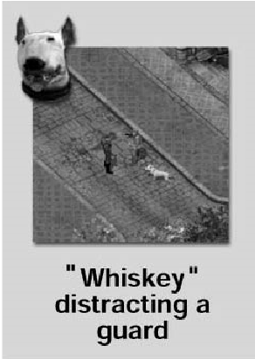“Whiskey” grew up in the New York submarine shipyard and became the mascot of the submergible E-423 in 1941. During an incursion into the North Sea, the ship was captured by a German patrol and taken to the base of La Pallice on the French coast. After “Whiskey’s” owner died, “Lupín” looked after him and he joined the Commandos group.

## SPECIAL CHARACTERS

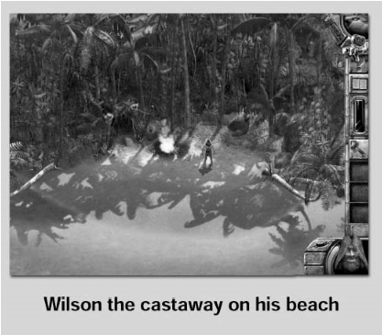In addition to the main characters described above, in

certain missions you will count on the help of Allied characters such as United States soldiers, Ghurkas, the French

Resistance, a Hindu spiritual leader, an exceptional prisoner by the name of Guinness and Wilson, the shipwrecked sailor on a not-soabandoned island, who will help you divert the enemy.

## THE ENEMY

You are already familiar with your men and some of their abilities. This section reveals important facts about your enemies. In different missions you will deal with German and Japanese soldiers. Although their behavior is similar, studying their weak points will help you gain the advantage and be able to defeat them on their own soil.

|  |  |  |  |
| --- | --- | --- | --- |
| **SKILLS:** “Whiskey” diverts enemies by barking and running around them. He carries small objects from one Commando to   |  |  |  | | --- | --- | --- | | 28 | another, crossing through fields  containing enemies. With his keen sense of smell he can detect mines, although he cannot deactivate them. He cannot climb ladders, but any Commando can put “Whiskey” in his Backpack and carry him around. | 29 | |

Enemy soldiers can see and hear your men. They can also be alerted by other soldiers or by alarms. If they see a corpse or something suspicious or hear an explosion, they will stare at this point and become more vigilant about investigating anything that may happen. It will be some time before they relax again.

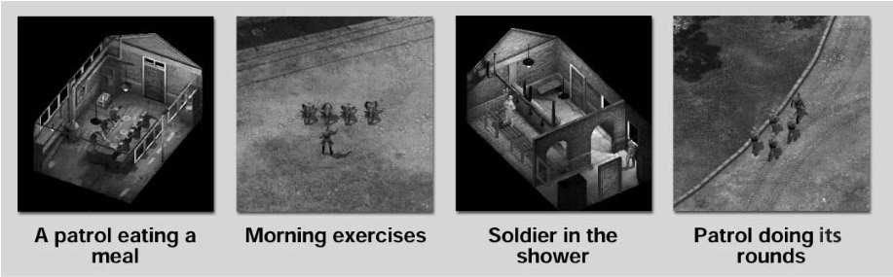

### GENERAL BEHAVIOR

Enemies will normally remain at their posts watching over a zone, busy with some activity or patrolling a particular area. When alerted, some of them will stay in their positions, but many will rush toward the point where something suspicious has occurred. You can find out which enemies will leave their posts by using the binoculars to observe them.

### MILITARY RANK

There are three enemy ranks: soldiers, corporals and officers. Their main difference is in the success the Spy has when issuing orders disguised as the enemy. His orders will be accepted far more easily by the lower ranked enemies than by the corporals. The officers will always recognize “Spooky” and “Seductress” in their short range area (see below). The SS officers will tell them apart immediately, even when they’re disguised.

### FIELD OF VIEW

Enemy sight consists of a triangular area divided into two parts. These parts are the short range area and long range area. In the long range area of their sight, enemy soldiers will not see your men immediately. It will take them awhile if your men are standing, and they will not see your men at all if the Commandos are crawling. Your men will also be oblivious to the enemy if they are disguised, under a shadow or against a wall.

During night missions enemies can see your men if they move into the beam of a lamp or floodlight.

When one or several enemies see one of your men, a blue line is drawn to show who has detected him. The enemy will now consider whether he is friend or foe. If after a period of time (long or short depending on the difficulty level you have chosen), you haven’t moved the Commando from that area, the enemy soldier(s) will eventually recognize him. The line will turn from blue to red and the soldiers will chase your man.

If you throw a packet of cigarettes or a bottle of wine, an orange line will indicate who has detected it and may go to get it.

When an enemy sniper aims at one of your men with his rifle, a crosshair icon will appear over your man’s head as the sniper prepares to shoot. If you don’t run for cover, your Commando will be killed.

Remember that the icon will not tell you where the sniper is located. You will have to act quickly and hope you run in the right direction.

### ALERTED STATUS

When an enemy’s field of view is green, he is relaxed and will tend to occupy himself with his own normal

duties — things he’ll keep doing as long as nothing arouses his

suspicion.

If the area is red, the enemy is clearly alert. This means that he will react immediately if he sees any of your men. If you wait a

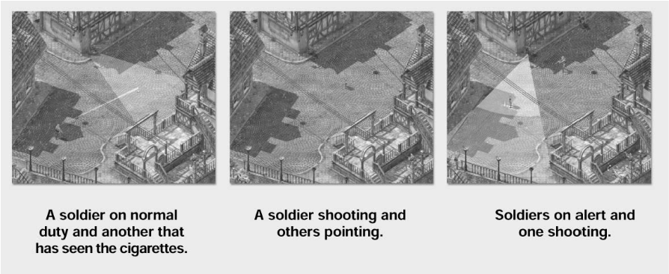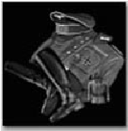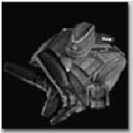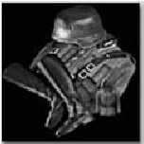

sufficient period of time, the enemy will return to his duties.

### WEAPONS

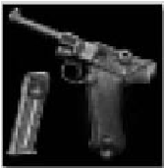Each enemy uses a weapon according to his rank. Corporals and officers use regulation pistols. The soldiers have rifles and machine guns.

Some enemies dressed as civilians do not carry weapons but are able to defend themselves with their bare hands. These are

|  |
| --- |
| 30 31 |

workers, executives and sailors. They are not a great danger for your firearms but they could sound the alarm and the real problems will begin. Some mechanics wear flame-proof suits and are resistant to flamethrowers, but not to your guns.

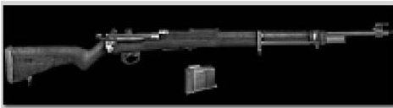

### SPECIAL UNITS

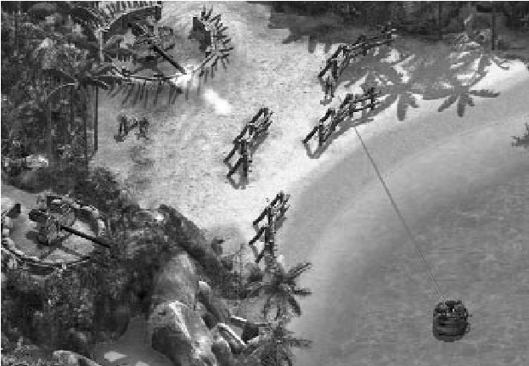

Elite snipers use precision rifles. They can see farther and they can see your men even if they are lying on the ground. At long distances they will undoubtedly use their rifles and, when close enough, they will use their pistols, which are less powerful than rifles but more effective at close range.

The grenadiers corps of the German army are a fearsome foe as they can throw grenades when outside and also through windows. A single grenade can kill all your Commandos if they are in the same room. Be very careful if you see a German grenadier.

When underwater, you may encounter groups of divers with harpoon guns. The range of their weapons is limited but they can be very dangerous.

Enemies also take up look-out positions and can be equipped with binoculars. They can spot you from a great distance and rapidly advise the guns to shoot at your position.

There are posts with heavy machine guns guarding strategic areas. If you can take control of these points you can turn the guns against your enemy.

### THE PATROLS

Patrols consist of several soldiers in formation and commanded by an officer. They make vigilant rounds and serve as escorts. When an alarm sounds they enlarge their normal routes to cover larger areas that will make your mission more difficult.

Some patrols can arrest your men and take them to prison. You will then have to rescue them so that you can complete your

mission. If a patrol attempts to arrest you, don’t resist them or you will be shot. If you do decide to run make sure that you can get away.

### OBTAINING INFORMATION AND RESOURCES FROM THE ENEMY

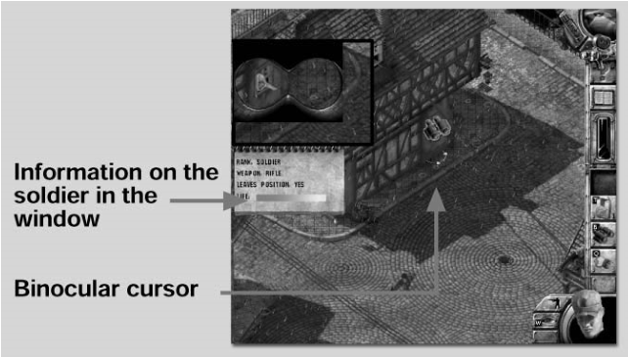Use the binoculars to get

additional information

about the enemy, such as

type of gun, health level and

if they will leave their position.

Inspect the bodies of dead or bound enemies as you may find valuable items. You can salvage their weapons, ammunition, explosive materials, uniforms and special items such as codes or keys.

The weapons that you take from enemies have limited ammunition and uniforms will disguise your men for a limited amount of time. Consequently you should try obtaining as many of these items possible.

### WAYS THE ENEMY CAN BE ALERTED

Enemies can see you, hear you and follow your footprints on snow or sand. If they encounter bound comrades or find a dead soldier they can sound the alarm. An enemy will do everything he can to find you during a certain period of time before going back to his normal duties.

Doberman guard dogs can see you and will bark while attacking you, attracting the enemy.

Wild animals will attack both you and your enemies. If you are skillful enough you can use wild animals to your advantage to attack your enemies.

### ENEMY VEHICLES

The enemy has various types of vehicles which they use to dramatic effect. Your Commandos can assume control of these vehicles but not if they are occupied by enemy soldiers. You can alternatively destroy the vehicles with rocket launchers, bombs, anti-tank mines and bazookas.

|  |
| --- |
| 3233 |

The best method is to find vehicles that are not currently manned by the enemy.

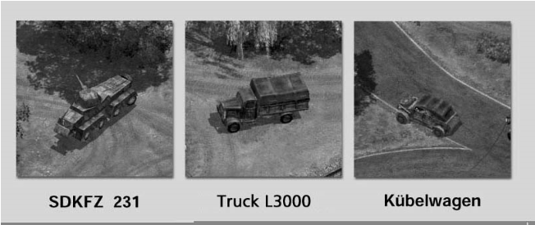

# EQUIPMENT

To use or activate some of the objects you will encounter on your mission, you will have to click on them with the LMB. Depending on the type of object it is, the action can execute immediately or not, as in the case of some weapons where the cursor will change its shape so that you can then use it as a target. The cursor may sometimes show a “Forbidden” sign, indicating that this action cannot be performed with the place or object that you were pointing to.

Some tools, like the decoy, can be activated remotely. After you place these objects, you can move away and activate them from a safe distance. Other objects are also available that you can use to distract or deceive the enemy. Your men are well trained and experienced specialists and you will very seldom encounter problems using weapons and equipment.

## OBJECTS selected with ONE CLICK

You can select all the objects in this category by clicking on the corresponding interface icon. Once selected, that item can then be used by the current character.

### CHANGING UNIFORM

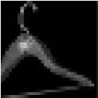All characters except for “Whiskey” have a normal uniform that they pack away while disguised as enemies.

### ENEMY UNIFORM

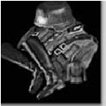All Commandos are able to use an enemy uniform. The most common way to obtain an enemy uniform is to steal it off an enemy’s back. Once an enemy is knocked out or killed, you can examine his Inventory and take his clothes. By wearing the

uniform, Commandos will escape the long range view of enemies (except SS Officers), as long as they do not act suspiciously.

### CORPORAL’S AND OFFICER’S UNIFORMS

The Spy alone can take advantage of these uniforms. When in possession of a corporal or officer’s uniform, he will convince the enemy that he is one of them.

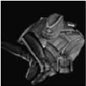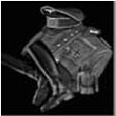

# 34

## DIVING EQUIPMENT

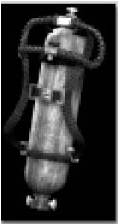When you click on the diving equipment, the Diver will put on his wet suit and oxygen tank that allow him to spend hours underwater.

## SNOW EQUIPMENT

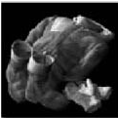It is absolutely essential that you wear this special equipment in the extreme colds of the Arctic in order to survive. Each character has his own snow uniform but, in case he loses it or doesn’t find it, he can try to obtain one from an enemy Backpack.

Unfortunately, enemy snow clothing only lasts for a limited time.

## NATASHA’S CLOTHING

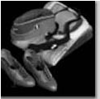“Seductress” changes her look and dress often during a mission. Every time you click this icon, she will decide what clothing is appropriate for the occasion and dress in it. It may well be a

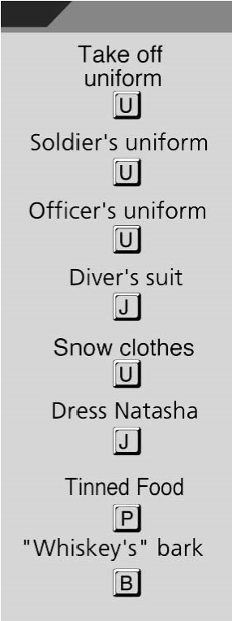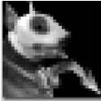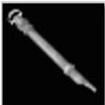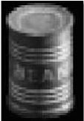Chinese costume or a German secretary’s dress. She can walk around scenarios rife with German enemies without arousing suspicion.

## RELEASE “WHISKEY”

“Whiskey” enjoys travelling inside the Commandos Backpacks and wants to go wherever the rest of your men go. If you want to place “Whiskey” on the ground, click his icon

on the interface.

## WHISTLE

This is the instrument that all Commandos use to call “Whiskey” when he’s needed.

## TINNED FOOD

You can find food in cupboards and closets, inside buildings and wherever enemies keep their provisions. All Commandos will need food supplies sooner or later to regenerate their health levels.

## “WHISKEY’S” BARK

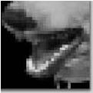A loud bark from “Whiskey” will attract the attention of all people nearby, giving your men

a golden opportunity to take advantage

of the distraction. 35

## OBJECTS THAT CAN BE PLACED ON THE SCENERY

All the following objects can be left or dropped on the scenery. Select the object on the interface and the cursor will change. Place the new cursor over the target spot and click the LMB to throw it. If the cursor shows a “Forbidden” icon, try to decrease the distance to where you wanted to throw it. To cancel this action, press the RMB anywhere on the scenery.

TRAP

CABLE TRAP

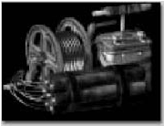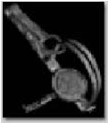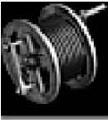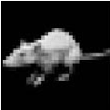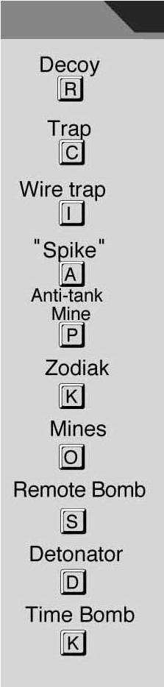

### CIGARETTES

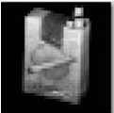Tobacco is a rare commodity during war time. If you are lucky you’ll find a packet inside a house or steal some from the enemy. Your men can throw the cigarettes to a certain point in an attempt to

entice enemy guards away from their positions.

### FISH FOOD

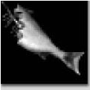The Diver and Green Beret can hide from danger when swimming underwater by camouflaging themselves in large shoals of fish. They place fish food in the water to attract the fish, who then form

a wall around them. The fish will move with the swimmer, hoping to receive more food.

### DECOY

To use a decoy you need the emitter model PHILIPS

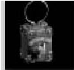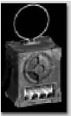

L12 and the switch that activates it. All the Commandos know how to operate the decoy. It is used to attract enemies by emitting a loud noise that the enemy then investigates.

### BOTTLE

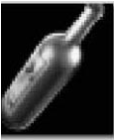Find bottles of wine in places where the enemy keep their provisions. As with cigarettes, the enemy will seldom resist the temptation of grasping a bottle of wine and drinking all of it.

The effect will put him to sleep for a while. If you fill the bottle with sleeping pills, the enemy will sleep until someone wakes him up.

### DOG FOOD

If you put some sleeping pills in the dog food it will turn a green color. You can then feed it to enemy dogs and put them to sleep. Later, you can recover

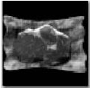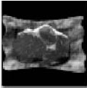

the pills and use them again.

### REMOTE BOMB

This powerful explosive can be detonated by remote control. The only person who dares to use it is the Sapper.

The Driver is in charge of studying the movements of the enemy and placing traps in the environment. Traps, deadly to those who step on them, can be put anywhere — the enemy will never notice them. Another good thing about traps is that the Driver can always recover a trap and use it again.

The cable trap is one of the more sophisticated wartime tools that the Driver uses. The cable is extended across narrow passages and corridors. Select one point of a wall with the cursor: this is where the cable will be tied. Then select a point for the other end. Once the cable is pulled tight the Driver

retreats and hides in a secure place to enjoy the show.

### “SPIKE” THE RAT

“Spike” is the Thief’s friend and obeys only his wishes. He has trained “Spike” so that when you select a specific spot on the scenery with the “rat cursor,” “Spike” runs there and performs a couple of somersaults to attract the enemy’s

attention. When he’s finished, Spike runs back to the Thief.

### ANTI-TANK MINES

|  |
| --- |
| protected areas. The Sapper can find them with the mine detector. He is the only  Commando who can do this. Click the LMB on the spot where you want to place a mine. Anti-tank mines explode only when a vehicle passes over them.  36 37 |

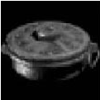You will find lots of these in ammunition boxes or buried somewhere, close to fences and other

### ZODIAK

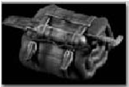The Zodiac is a type of boat used by the Diver, who always carries it in his Backpack. It opens when you select it with the cursor. Use it as transportation for your men as well as other people.

### MINES

“Whiskey” can smell them and the Sapper can find them with the mine detector. Only he can deactivate and pick up mines. He can them place them at strategic points. Allied soldiers will not set off mines placed by the Sapper.

### TIME BOMB

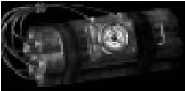Once the Sapper activates a time bomb he has 30 seconds to escape before it explodes.

### SMOKE BOMB

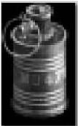The smoke bomb creates a curtain of smoke that masks your men from the enemy’s field of view for a short while. Be prepared to move quickly to take advantage of it while it lasts.

## OBJECTS selected with Two clicks

To use the following elements, click once on the corresponding icon on the interface and then click again with the new cursor on

the object or place you want to use it. To go back to the normal “Arrow” cursor, click the RMB anywhere on the map.

### BINOCULARS LEICA SLC 8X56

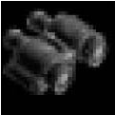The binoculars can be used by all the characters. You can obtain binoculars from enemy guards and lookouts or find them in some cabinets. They are an extraordinary tool for spying from exteriors into interiors. If you click with the binoculars on an enemy, you will

get information about him.

### WIRECUTTERS

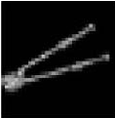All the Commandos can use these to cut through fences and cables. Beware of electrified fences: you must disconnect them from their power supply prior to cutting them.

You will find the wirecutters in garages, stores and in the Backpacks of enemy mechanics.

|  |
| --- |
| The Sapper is trained to clear a path through minefields for his comrades, detecting dangerous anti-personnel and anti-tank mines with his mine detector. You can sweep for mines, deactivate them and put them in his Backpack for use when necessary.  BURY  The Green Beret uses his shovel to dig a hole in the ground and bury himself. Unless someone sees him digging, once buried he is undetectable.  LOCKPICKS  With the lockpicks the Thief is able to open all metallic ammo boxes and many doors. To open doors, he must enter a house and open the door from the inside.  39 |

### MINE DETECTOR

### FIRST-AID KIT

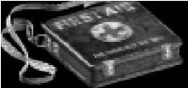Find first-aid kits in various areas in the mission. Each kit has several doses that you can use by clicking the “Syringe” cursor on the characters. The doses can be applied

to any Commando or Allied comrade to regenerate health.

### SNEAKING BEHIND ENEMIES

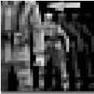The Thief is a master of sneaking up close to an enemy’s back without being noticed by his victim. He can then look inside the soldier’s Backpack for anything of interest. To use this ability, click on

the chosen enemy soldier with the “Sneak Up To” cursor. Since the Thief moves at the same speed as the enemy he is not seen. However, other enemies nearby have no problem detecting him.

### BLOWTORCH

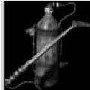Both the Sapper and Driver can use the blowtorch. It can prove very useful for fixing and building things while on a mission. You can also use it to open metal doors and even as a weapon.

Search the map to find it.

### SLEEPING PILLS

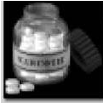These can be used with bottles of wine and with meat which can be fed to dogs. When an enemy drinks the wine, he will fall asleep until the end of the mission or until a fellow soldier wakes him up.

### LIPSTICK

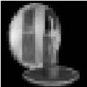Natasha uses her lipstick to distract the enemy.

Choose your victims by clicking on them with the “Lipstick” cursor and they will be momentarily blinded by her beauty.

### GRAPPLING HOOK

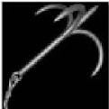The Diver uses the hook to place traps for the enemy. Fix the hook to a wall by clicking the “Hook” cursor on the bottom part of the wall and clicking again where you want the Diver to stand and pull the rope. Pulling the rope causes stress and his Stamina Bar

decreases. If “Fins” runs out of stamina he must set the trap again after recovering. Also use the hook to scale walls when no ladders are at hand. Click at the top of the wall to fix the hook

40 and climb the rope.

### ROPE LADDER

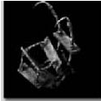Not all characters have the ability to climb walls like the Thief. Therefore, the rope ladder comes in very handy. It can be thrown from any height, whether from windows, hand rails or

balconies. Throw the ladder from above. When you are outside, click

the “Ladder” cursor on the floor. To descend, click on the ladder while

pressing the “Shift” key. The ladder highlights and shows the up and down cursor. Click the LMB and you will descend. You also collect the ladder from above. Press the “Shift” key as you place the cursor on the top of the ladder and the “Pick-Up” cursor will be displayed. Click the LMB to put the ladder in your Backpack. Using the ladder inside a building requires more expertise. When you want to exit a room through the window, click on the ladder with the “Ladder” cursor. The ladder will be extended and you will be able to use it normally. To retrieve the ladder you must select the “Examine” icon and click on the window. When the view changes, hold down the “Shift” key and click the LMB at the top of the ladder.

ISSUE ORDERS TO THE ENEMY

SHEETS

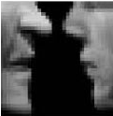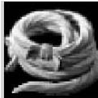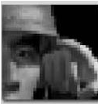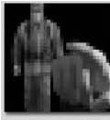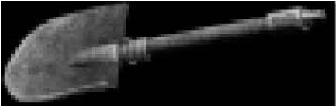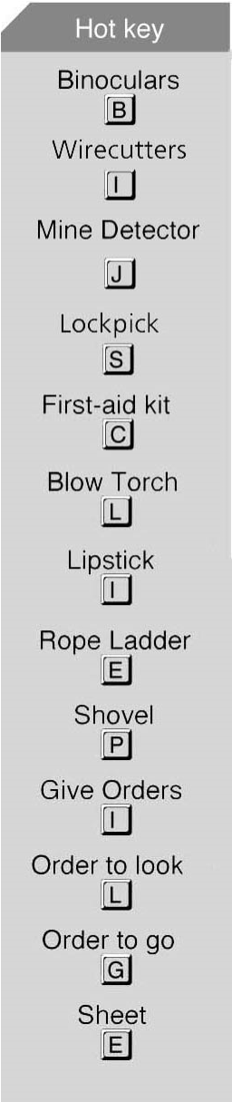

### SHOVEL

The Driver enjoys digging holes to form traps for enemies.

The Spy is the only one who can do this. He needs to be disguised as an officer to attract the attention of enemy soldiers.

### ISSUE “LOOK AT” AND ‘GO TO” ORDERS TO THE ENEMY

The Spy can issue “Look at” and “Go to” orders to the enemy to make them look in a certain direction or move to another position.

Inside Colditz prison the beds are many but the ladders are scarce. Steal some sheets and tie them together to form a provisional ladder to use to escape through the window. An old trick but very effective.

41

# WEAPONS

Weapons are the Commandos’ main tools. You start missions carrying some weapons; others you must find. When you select a certain firearm, the cursor changes to a crosshair that indicates if the target is in range. If it is red you are too far from your victim.

## MACHINE GUN MP40

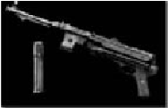This is an automatic firearm, very light, which fires in tremendous bursts but has limited ammunition. Its wide range of action makes it a fearsome weapon. Find machine guns and

ammunition or take them from enemy Backpacks.

## PISTOL

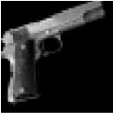The most often-used pistol is the COLT 1911 A, which has unlimited ammo. Most of your men know how to use it and they always carry one.

## HIT, TIE AND GAG

Some of your men have awesome strength. Their fists are powerful weapons and they can hit and daze even the biggest enemies. Once enemies are on the floor, your men will easily tie and gag them when you press the “Shift” key and click the LMB over the victim. You can then take the contents of the enemies’ Backpacks. Enemies remain tied until a fellow soldier frees them.

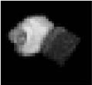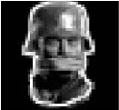

## KNIFE

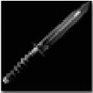The FAIRBURN assault knife has a double blade and a combat grip. The Green Beret approaches his victims and delivers a single mortal wound with the knife. The Diver prefers to throw it.

## ROCKET LAUNCHER PIAT

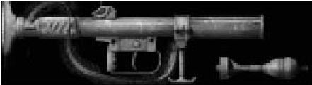Very light and powerful, the ammunition is a separate part. The Sapper uses the rocket launcher to fight armored troops.

## GAS GRENADES

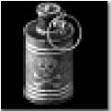This is a non-lethal bomb that the Driver uses, especially in enemy crowded areas. The grenade creates a thick cloud of gas that dazes all enemies in the area, but does not affect Allied soldiers.

## RIFLE

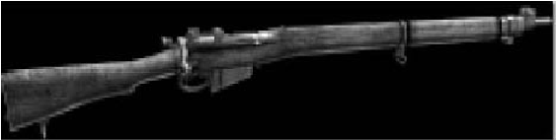This rifle, used by the Allied forces, is

a Lee-Enfield nº4 MKI with

unlimited ammunition. The

Commandos will have the chance to steal some KARABINER 98K rifles from the enemy. If you are a

good shot it will take only one bullet to kill an enemy. The KARABINER has limited ammunition.

## SNIPER RIFLE

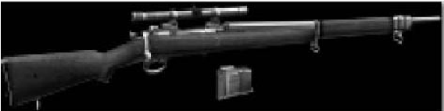The rifle used by your men is the M1903, 30 SPRINGFIELD with unlimited ammunition. You can obtain some GEWEHR 98 rifles from the

SYRINGE

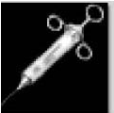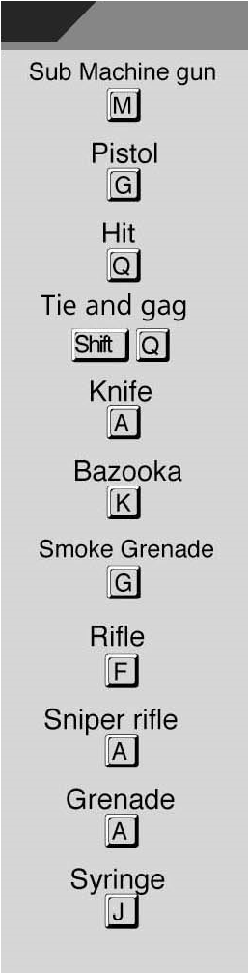

enemy. Again, you will have to get these from their Backpacks — and you will need ammunition. These are very long range rifles that only “Seductress” and “Duke” can use.

## HAND GRENADES

These are number 36 M, Mk1 “Mills Bombs.” The Sapper throws them through doors, trap doors and windows. Grenades are very handy weapons but extremely noisy.

This is the Spy’s favorite weapon. Its effect depends on the number of doses he injects into his victims. One dazes them, two renders them senseless and makes them fall. Three kills them.

## BOTTLE

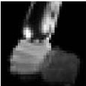Most people would rather drink the wine than use it as a weapon, but “Seductress” won’t hesitate to break it on anyone’s head if it aids the successful completion of the mission.

## HARPOON GUN

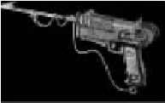A very important weapon for the Diver. Without the harpoon gun he would be unable to defend himself and the others from sharks, crocodiles and enemy divers.

## MOLOTOV COCKTAIL

|  |
| --- |
| 42 explosive cocktail kill several enemies at once.43 |

Some gasoline and a little spark can make this

# VEHICLES

In many of the missions you will find different types of land, sea and air vehicles. Your Commandos can use them to move around the map and to infiltrate enemy lines.

## DRIVING VEHICLES

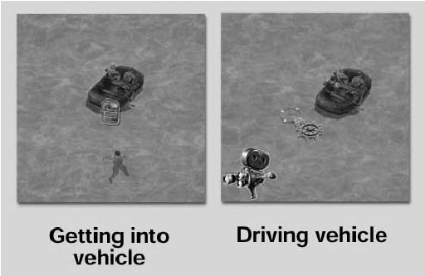All your men can drive vehicles as long as the vehicle is in working order and not occupied by the enemy. To drive, select the vehicle by pressing the “Shift” key and clicking the LMB on the vehicle you want to enter. When a Commando gets into a car, the camera will follow him and the cursor will change into a “Wheel” icon. To move, click the “Wheel” icon on the part of

the map that you want to move to and the vehicle will travel forward or backward towards that point. To move faster, double-click the LMB on the desired direction.

You can also use the cursor keys on the keyboard. To increase speed of movement, press the “Shift” key at the same time as the cursor keys.

If you are inside a vehicle and the enemy detects you they will shoot at you, unless the Spy is driving the car disguised as an officer. If you are in a balloon, the enemy will not detect your presence. This does not apply if you drive recklessly, in which case the enemy will shoot at you regardless of who or where you are.

In some cases you will be able to shoot from an armed vehicle. To do this, press the “Ctrl” key and click the LMB on the target with the cursor.

To make a Commando exit a vehicle, select him by clicking on his “Face” icon at the top of the screen or using his direct access number key. Then press the “Exit” icon or the “X” key.

If you order a Commando to exit a boat, remember that he will have to swim to the shore. If you use a balloon, it must take off before it can move.

Click the LMB on the “take off” icon and the balloon will float skyward. The balloon is controlled in the same way as other vehicles.

When flying you will not be spotted by the enemy unless they spotted you taking off. When you want to land, find a suitable area, click on the “Land” icon and the balloon will land.

# SINGLE PLAYER GAME

If you decide to play Commandos 2 as a single player, there are certain steps you must take to set up.

## Setting Up

Begin by selecting your player name and mission. You can create a new player name, or use one you’ve previously created. If you are starting Commandos 2 with a new player (for instance, the first time you play), you must create your player identity and assign it a name. Initially, a default player is suggested that you can choose to use, delete or change.

As this is the player’s first encounter, you will only be granted access to the training missions. As your experience increases, you will be allowed to risk the Commandos and take on the missions.

|  |
| --- |
| 44 45 |

Each new player you create will start from scratch, with no experience, and you will have to train him from the beginning.

# MULTIPLAYER GAME

When you decide to enter a multiplayer game, you must select a series of options including choosing the type of connection and your character before you can start playing. Some of the game characteristics will be different from in the missions in single player games.

## SETTING UP

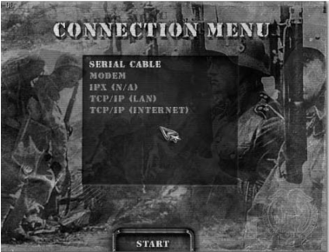In multiplayer mode, one player is in charge of creating the game and ensuring the configuration is correct. He must wait for the other players to join and then he will start the game.

SELECTING THE CONNECTION

You can play Commandos2 with other players either over a Local Area Network or on the Internet. If you select the Internet option, you must enter the IP address of the host player. Alternatively you could host your own game and invite your friends. Make sure to give them your IP address. If you do not have your own IP address, the one your Internet Service Provider assigns you may change from one session to another.

### SELECTING THE MISSION

Once you choose a connection method, a new window will appear where you can choose whether to join a session that is about to start, or create your own. To enter a mission, click the LMB on it twice or select it and click the icon at the bottom of the window.

If you are hosting the game, you will only be able to play with the number of players allowed in the mission. Note that you will only be able to choose from the missions available, and these will depend on the missions you have previously played in single player mode. On the other hand, if you want to join a game started by another person, it is not required that you have access to that particular mission in order to play it.

SELECTING YOUR CHARACTERS

In this screen you will see the names of all players who have decided to join the game, each of them shown in a

different color. Each player must choose at least one character.

The faces of the characters will be outlined by the colors of the players who have selected them. Use the chat box at the bottom

of the screen to talk with the other players.

Before the game can start, pay attention to the following points:

* All the characters involved in the mission must be assigned beforethe game can begin.
* One player can have several characters.
* There can only be one of each character, so you will have to distributethe characters among yourselves.
* Only the host can change the difficulty level.
* Only the host can start the mission, either from the beginning or froma saved game file.
* If the mission is started from a quick-load (instead of from thebeginning) players not involved when the game was saved will not be allowed to join.

|  |
| --- |
| 46 47 |

If any of the above conditions are not met, the game will not start. Instead, a window will pop up with an explanation of the problem. When all of you are ready, the mission can be started, Good luck!

In-game differences

## Between single player & Multiplayer

Some aspects of the game function differently in multiplayer when compared to single play, as explained in the list below:

* The only way you can save the game is by using the quick-save feature.As a result you will only be able to save the last position.
* Every time a player decides to save or load the mission, all teammembers will automatically do the same. As some computers will be slower than others, it is highly likely that a window will pop up indicating that the game is waiting for the slower ones to finish saving.
* If one of the players leaves the game or his connection is lost, a windowwill appear explaining that the mission cannot continue.
* If there are connection problems, a window may appear informing you ofthe problem. This doesn’t mean that the mission is over. Some players will have to exit if it looks like the connection will not improve.
* During the mission you are able to chat by pressing the “Ctrl” and“Enter” keys simultaneously.
* In multiplayer games, the game will not pause when you open yourNotebook, use your Backpack, or perform any other duties.
* If a player is controlling several characters, they will be able to exchangeobjects between their Backpacks as per usual, exactly as in the single player missions.
* If characters controlled by different players want to exchange items, itwill require some “good manners” protocol that has to be explained:
  + The exchange between characters controlled by different players canonly be done one at a time, i.e., a Red Player Green Beret with Green Player Sapper. You are unable to exchange items with several characters from one player and characters from another player. Exchanging items is limited to two players at a time.
  + If two players are exchanging objects between their respectivecharacters and a third player appears, that player will have to wait for the others to finish before exchanging with one of them.

# 48

* When you decide that you want to exchange objects with another player (remember one player, one

character), one of you will have to begin the dialog using

the “Magnifying Lens” icon. Both players’ screens will

display respective windows asking for confirmation. If both

of them accept the transaction, the faces and the Backpacks

of both characters will be shown on both screens.

* The exchange can only be carried out by placing objects in someoneelse’s Backpack. You cannot help yourself to other players’ Backpacks. This means, for example, that if you want to take the shovel from a colleague’s Backpack, you’ll have to ask the player for it. Use the chat (remember, “Ctrl”+”Enter”) and if you agree, then that player will have to put the item in your Backpack. You’ll never be able to take it directly.
* If at any time one of the players decides to terminate thetransaction, he is able to do so.

49

|  |  |
| --- | --- |
| **GONZO SUÁREZ**  **JON BELTRÁN DE HEREDIA OLAZABAL**  **JORGE BLANCO GARCÍA**  **PROGRAMMERS** | **Author, Commandos 2: Men of Courage**  **Project Lead and Game Design**  **Lead Programmer**  **Art Director** |
| Lead Physics Technology | ISMAEL RAYA ROA |
| Lead A.I. and Interface Technology | ELISA FERNÁNDEZ ALONSO |
| Lead Consoles and A.I. | RAÚL HERRERO DOMINGO |
| Missions and Network | FERNANDO JOSÉ COLOMER PÉREZ |
| Lead Graphics Technology | JAVIER ARÉVALO |
| Internal Engine | VICENTE RIBES RIPOLL |
| Graphics Technology | JORDI ROS AZNAR |
| Physics | RAÚL RAMOS GARCÍA, ENRIQUE GARCÍA VERA. JOSÉ Mª CALVO IGLESIAS |
| A.I. | ENRIQUE JOSÉ SAINZ NAVARRO, TOMÁS  FERNÁNDEZ ALONSO, CÉSAR BOTANA RIVERA |
| Missions | ARTURO COLORADO GARÍN |
| Tools  **ARTISTS** | JULIÁN PERÉZ |
| Lead Artist | FRANCISCO JAVIER SOLER FAS |
| Animator | JAVIER ABAD MORENO |
| Senior Artists | MARCOS MATÍAS MARTÍNEZ CARVAJAL, DANIEL  ESTIVAL HERNÁNDEZ, JORGE FERNÁNDEZ  MELÉNDEZ. IFERNANDO HUELAMO GARCÍA |
| Artists | JOSÉ MANUEL PÉREZ DE VRIES, LUIS CALERO SERRANO, JAVIER JESÚS LEÓN CARRILLO. FCO.  JAVIER TEJADA ZACARIAS. DANIEL MORENO DÍAZ |
| Junior Artists | JESÚS RUIZ LUNA. RAÚL OVEJERO SAINZ. OMAR  ANTONIO PARADA MARTÍNEZ. DANIEL OLAYA ORTÍZ |
| Assistant Animator  **PRODUCTION AND SOUND** | JOSÉ MANUEL LIEBANA SANTAMARIA |
| Chief: Production, Music & Sound FX | MATEO PASCUAL PASCUAL |
| Lead Missions Designer | JOSÉ MANUEL GARCÍA FRANCO |
| Context Design | RAFAEL MARTÍNEZ GARCÍA |
| Mission Design & Documentation  Marketing Material | ARMANDO SOBRADO CROS, JORGE SÁNCHEZ |
| Coordination & Manual | RAQUEL LANDALUZE GARRIDO |
| Illustrator | ALFONSO PARDO |
| Production & Manual | MIGUEL SANTORUM GONZÁLEZ |
| Production | EDUARDO TOMÁS ALABAU |
| Testing | HECTOR PIÑERO GÓMEZ |

# CREDITS

# 50

## **ADDITIONAL PROJECT STAFF**

PEDRO PABLO AULLO, JUAN MANUEL GARRIDO,

RAFAEL BARROSO, HUMBERTO CUENCA, JOSÉ

FERNÁNDEZ, DAVID GURREA, LUIS SÁNCHEZ, LUIS

TOMÁS REDONDO, ALEJANDRO CAMAÑO, JOSÉ

JULIO GARCÍA, JORGE RAMÓN ACEREDA, MANUEL

GUILLÉN, LUIS PONS, OSCAR CUESTA, JAVIER

|  |  |
| --- | --- |
| **SPECIAL THANKS**  **EIDOS CREDITS** | FERNANDO RUIZ, PALOMA MESA, IGNACIO  GÜEJES, HECTOR CIVIT, OSCAR MARTÍNEZ,  VIRGINIA DE LA PEÑA, RICARDO Mª MARTÍNEZ,  DAVID NOTARIO, GERMÁN MONTÉS, JOSE LUIS  LÓPEZ GALLEGO |
| VP of Development | NICK EARL |
| Producer | TOM MARX |
| QA Manager | BRIAN KING |
| Assistant QA Managers | COLBY McCRACKEN, MIKE ORENICH |
| Lead Tester | ERIK KENNEDY |
| Assistant Lead | CARLO DELALLANA |
| Testers | ERUCH ADAMS, JESSE ANDREWS, NEVIN CHOU,  JEFFREY LOWE, FERNANDO ROBLES |
| VP of Marketing | PAUL BALDWIN |
| Marketing Director | CHIP BLUNDELL |
| Product Manager | MATT KNOLES |
| PR Manager | MICHELLE SEEBACH |
| Marketing Coordinator | RANDY STUKES |
| Inner Office Asset Distribution | LAUREN HICKEY |
| Casting & Voice Production | E. MOTION TECHNOLOGY |
| Cast | GERRY KERSEY, JOHN TIERNEY, ANTHONY MULLIGAN, DAVID FENWICK, FIONA BRUCE |
| Package Design | MOORE DESIGN GROUP |
| Manual | HANSHAW INK & IMAGE |
| Special Thanks | ROB DYER, DAVE COX, KEVIN WESTON,  MIKE KELLY, KIM PENDLETON,  KEN SCHMIDT, DANIEL EARL,  MIKE SCHMITT, MIKE McHALE,  CLAYTON PALMA, T MANN,  BRYAN DAVIES, KJELL VISTAD,  LI SHEN |

GARCÍA-LAJARA

51